DBS Lab 2

Name:

1. Perform a SQL Dump of your example database using Sequel Pro. Do not Upload it to FSO. This is for your backup purposes. (1pt)

2. Create a new user (as yourself or favorite movie character) by inserting into the users table. As the userId is a varchar, choose a random, but unique value. Be sure to populate ALL columns. Paste the SQL below. (1pt)

insert into users
(userId, firstname, lastname, middlename, username, password, DOB, gender, occupationId, userStatusId, userTypeId)
values ('B', 'Sasuke', 'Uchiha', '---', 'DarkHokage', 'Il0veNarut0', '1996-01-10', 'M', 456, 1, 1);

3. Create 2 new orders for the user created in question 2 by inserting into the orders and orderItem tables. Place at least 1 item per order. Paste the SQL below. (1pt)

insert into orders
(userId, orderDate , shippingDate)
values ('B', '2016-09-29 13:57:18', '2016-09-30 16:00:00');
insert into orders
(userId, orderDate , shippingDate)
values ('B', '2016-09-29 14:50:18', '2016-10-01 16:00:00');
insert into orderitem
(orderId, itemId, quantity)
values (21278, 1, 1);
insert into orderitem
(orderId, itemId, quantity)
values ( 21279,2, 1);

4. Assign 2 DVDs to the user created in question 2. Paste the SQL below. (1pt)

insert into userdvd
(userId, dvdId)
values ('B',7);
insert into userdvd
(userId, dvdId)
values ('B',13);

5. Assign 2 vehicles to the user created in question 2. Paste the SQL below. (1pt)

insert into uservehicle
(userId, vehicleId)
values ('B',10000);
insert into uservehicle
(userId, vehicleId)
values ('B',32071);

6. Write a SQL statement to return the users (userId, firstname, lastname) and their orders (orderId), only for users that have placed an order. Join the users and orders tables. Paste the SQL below.(2pt)

select users.userId, firstname, lastname, orders.orderId from users
join orders
on users.userId = orders.userId;

7. Write a SQL statement to return all users (limit 200) and orders if available. When joining the 2 tables, be sure to choose the correct type of join. Paste SQL below. (2pt)

select * from users
left join orders
on users.userId = orders.userId
limit 200;

8. Write a SQL statement to return all users (userId, firstname, lastname) who have not placed an order. Again, when joining the users and order tables, choose the correct join. (limit 200) Paste SQL below. (2pt)

select users.userId, firstname, lastname from users
left join orders
on users.userId = orders.userId
where orders.orderId is null
limit 200;

9. Write a SQL statement to return all orders (orderId, orderDate), the information of the user who placed the order (userId, firstName, Lastname), and their items ordered and quantities (itemName, quantity). (limit 200)Paste the SQL below. (2pt)

select orders.orderId, orders.orderDate, users.userId, firstname, lastname, itemName, quantity from users
join orders
on users.userId = orders.userId
join orderitem
on orders.orderId = orderitem.orderId
join item
on orderitem.itemId = item.itemId
limit 200;

10. Alter the order table to add a column called “destinationState” and populate the existing orders with state abbreviations from the states table. Paste the alter table SQL statement below. You can manually or with an insert statement, populate the destinationState column with ANY valid state. (2pt)

ALTER TABLE orders
ADD destinationState VARCHAR(2);
update orders
set destinationState =
(
select state
from state
order by state asc
limit 1
);

11. Create a foreign key between the tables, state and orders. IE: From table orders, column destinationState to table state, column state. FK always points at a PK. Paste SQL (alter table) below. (2pt)

ALTER TABLE orders
ADD constraint fk_destinationState
foreign key(destinationState)
references state(state);

12. Select all users who have a lastname of “Steady” and display their full name as a single field. Paste SQL below and the time the query ran. (2pt)

select concat(firstname, ' ', lastname) as fullname from users
where lastname = 'Steady';

13. Create an index on the last name column for the users table. (A regular index, not unique) Paste SQL below. (2pt)

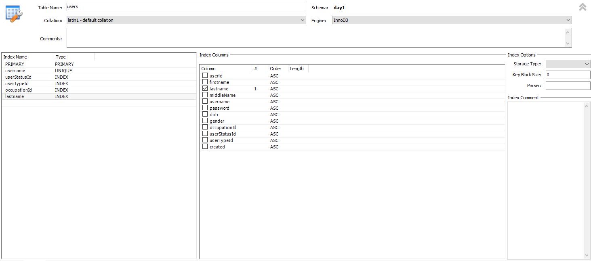
Alter table users
add index (lastname);

14. Rerun the query from question 12. Paste SQL below and the time the query ran. (1pt)

select concat(firstname, ' ', lastname) as fullname from users
where lastname = 'Steady';

15. Get the count of all users with a last name ending in “ing”. Paste SQL and results below. (2pt)

select count(*) from users
where lastname like '%ing';


16. Get the count of all users with a first name starting with “J” and who are employed. Users who do not have an occupation are considered unemployed. Paste SQL and results below. (2pt)

select count(*) as Employed from users
where firstname like 'J%' and occupationId is not null;


17. Create an ER diagram of the database using MySQL Workbench. Export the diagram as an image. (2pt)

To complete this assignment, upload this word doc and your ER Diagram image to FSO.

